Blouberg
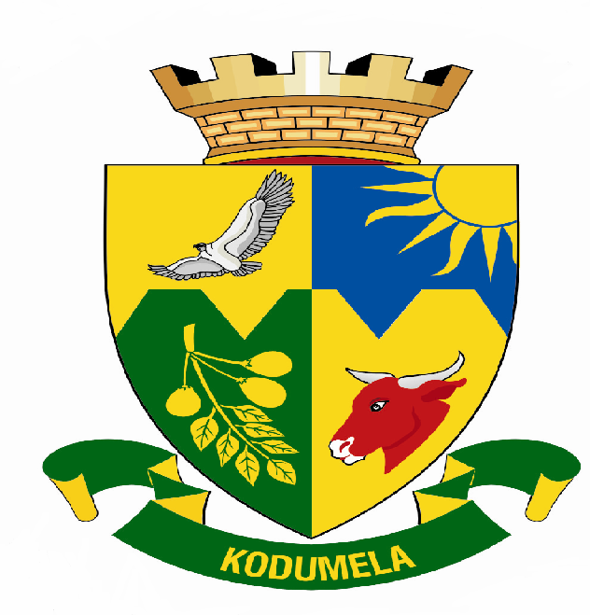
Municipality
P.0 Box 1593
SENWABARWANA
0790
Tel: 015 505 7100
Fax: 015 505 0568/0296
E-mail:info@blouberg.limpopo.gov.za

Media Release

Sporting weekend in Blouberg – Indigenous Games & Capricorn District Ball Games

Blouberg Municipality in collaboration with Love Life and SAPS Mara will have the indigenous games on 27 January 2007 at 09h00, Matlare Sports Ground in Indermark. The games are a build up to the tournament that will be held in 17 March 2007.

We encourage the young people to fully participate and take pride in our traditional sporting activities. The codes include morabaraba, moruba, diketo,kgati and others. The best players will be selected to compete in the coming tournament against teams from Johannesburg.

The problem of crime, teenage pregnancy, alcohol and drug abuse has prompted the three (Blouberg Municipality, SAPS Mara & Love Life) to work collectively in a endeavor to build a winning, dedicated and ambitious young generation.

In a community that is faced with so many problems, sport is the tool that will not only unite but also give hope and confidence to sports fanatics in the area.

The Capricorn Ball Games will also be held on Sunday, 28 January 2007 at 10h00, Senwabarwana Showground. The sport tournament includes the following sporting codes soccer, netball, volleyball, softball, handball, rugby, cricket and basketball.

You are therefore invited to embrace with us our heritage on the aforementioned date.

Issued by Communications on 26 January 2007.

For enquiries contact:
Manager Communications: Ms Phuti Matlou
Tel : 015 505 7100
Cell : 083 395 8417
Fax : 015 505 0296

